

**Text Classification Using Neural Networks and the Word2Vec Methodology**

|  |  |
| --- | --- |
| **Author:** | John Rey Juele |
| **Student ID:** | 15167798 |
| **Supervisor:** | Farshad Toosi |

***Interim Report***

B.Sc. Computer Systems

Department of Computer Science and Information Systems

Table of Contents

1. Project Summary 3

2. Introduction 4

2.1. Context/Motivation 4

2.2. Objectives 5

3. Research 6

3.1. Artificial Neural Networks 6

3.1.1. The Inspiration 6

3.1.2. The Application 7

3.2. Word2Vec 11

4. Current Progress & Future Plan 14

References 15

# Project Summary

For my final year project, I will be developing an application that will take a piece of text or a set of texts as input and will then label them with a topic or subject that best describes them. This project makes use of concepts and ideas that are brought out in the fields of machine learning and natural language processing and the objective is to use these to create software that fulfils a need in real life.

NOT YET COMPLETED

# Introduction

## 2.1. Context/Motivation

As we are living in a digital age, information has become widely distributed and therefore easily accessible. Even though we have not completely moved on from physical books and other paper-back publications, more emphasis has been placed on making information available electronically. 80% of the information available to us, both in physical and electronic form, is in text format (Korde & Mahender, 2012).

Helping computers understand and process human language has been an active area of research in computer science especially in the field of natural language processing (NLP). One of the subareas of this field is in the classification of text. Computers are being used as tools to automate work especially in analysing and processing text with a view of classifying them. With this in mind, text classification is a contributory building block in many NLP applications. Following on from this, the technological environment today has encouraged researchers to place more attention in incorporating and implementing mechanisms of text classification in everyday, practical tasks. We can actively see this in action with the prevalence of machine learning today regarding web searching, sentiment analysis and data filtering (Aggarwal & Zhai, 2012), as well as in digital assistants such as Apple’s Siri and Amazon’s Alexa.

It has always been an interest of mine to dabble in the field of machine learning and to gain an understanding on how the resources of computers can be manipulated to mimic and simulate human-like intelligence and learning. Communication and language is an integral part of being human as well as of society as a whole. I am curious to discover the nuts and bolts that operate underneath the machine learning technology of today, especially on how they perform human-like tasks such as understanding text.

## 2.2. Objectives

NOT YET COMPLETED

# Research

## 3.1. Artificial Neural Networks

An artificial neural network (ANN) is an “information processing paradigm” that takes inspiration from the workings and the operation of the biological brain (Stergiou & Siganos, n.d.). ANN’s are not necessarily an algorithm; that is it follows a specific and concrete set of steps to solve a particular problem. They can be seen more as a paradigm or a framework as to how to structure and conceptualise the program.

### 3.1.1. The Inspiration

Artificial neural networks is inspired by our brains which is comprised by a large network of neurons. A neuron is just a single nerve cell that transmit electrical signals from one end to the other.

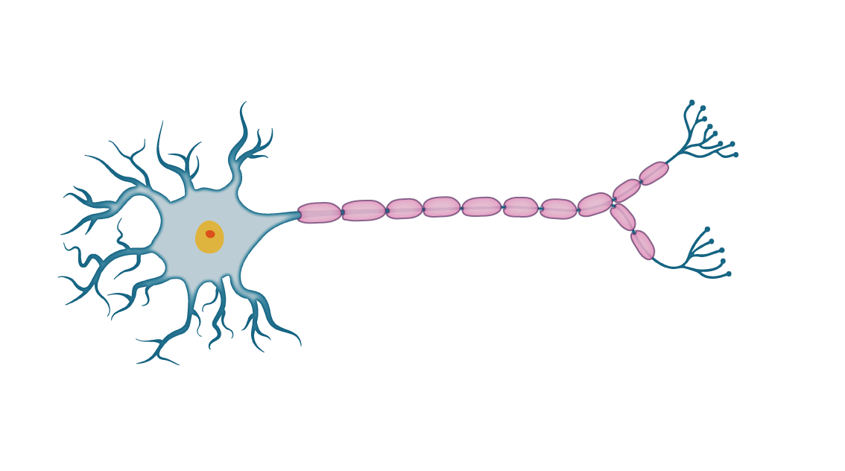

Cell Body

Nucleus

Dendrites

Terminals

Axon

Fig. 1. A Neuron

In the case of the diagram above, the electrical signal would enter the neuron through the dendrites which will then be processed inside the nucleus. It is only upon reaching a certain threshold that an output signal would be produced which is then sent through the axon and exists through the synapses within the neuron’s terminals (Rashid, 2016, pp. 41-43).

### 3.1.2. The Application

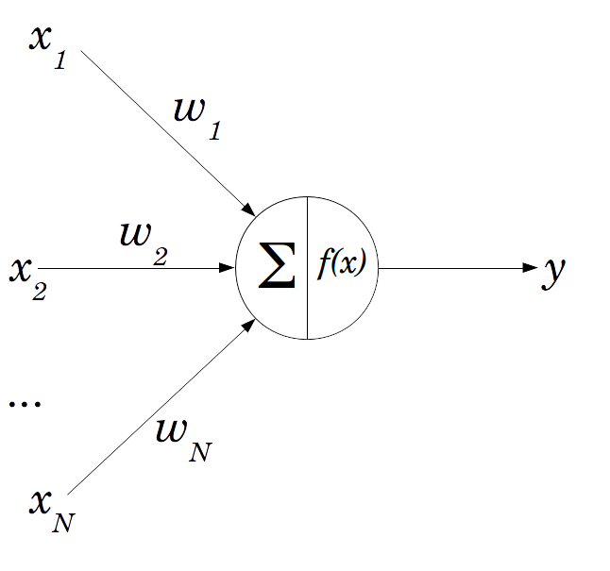We can model an artificial neuron like so:

Fig. 2. A Perceptron

The official name of an artificial neuron is a perceptron which can act as a single processing unit of an ANN (Rosenblatt, 1958). The main components of the perceptron are:

* **The weighted inputs**

There can be N inputs to this neuron which are also weighted. The weights on each connection signifies the strength of that connection and therefore influences the processing and ultimately the output of that perceptron. These weights are assigned random values initially. They can be seen as the dendrites from the biological neuron.

* **The neuron**

Within the neuron itself is where the processing takes place. Two main processes takes place. The “∑” or sigma signifies the summation of the inputs in the form:

$$sum=\left(x_{1}*ω_{1}\right)+\left(x_{2}*ω_{2}\right)+⋯+\left(x_{N}*ω_{N}\right)$$

As stated earlier under the biological brain, a certain threshold has to be met before the output is fired out of the neuron. This is modelled using an activation function: $f\left(x\right)$ where we pass the sum into that function. There are many types of activation functions such as the step function and the sigmoid/logistic functions (Rashid, 2016, pp. 44-45). The result of that function will be that neuron’s output or in other words its *activation value.*

Just like the brain is a network of neurons, we can model a network of perceptrons like so:

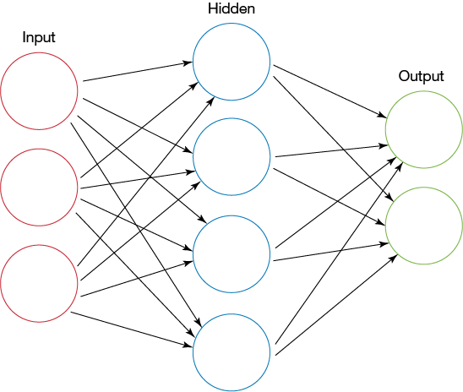

Fig. 3. A feed forward neural network

Each circle is a neuron/perceptron where the output of that neuron will act as the input of the next neuron. I should also note that connections between neurons are weighted (as weights are not included on the above diagram). In a typical neural network architecture, there are three layers: the input, hidden and output layers. The number of nodes in the output and input layers are dependent on the problem domain while the number of nodes in the hidden layer is arbitrary.

In order to produce a guess out of the neural network, it must perform a feed forward mechanism through the network. Once executed, the activation value of each node in each layer is calculated until it reaches the output nodes. The activation value of the nodes of the output layer is the neural network’s guess. I should also point out that there is a more efficient way of performing the feed forward algorithm. Everything on the neural network can be represented as matrices (Nielsen, 2018).

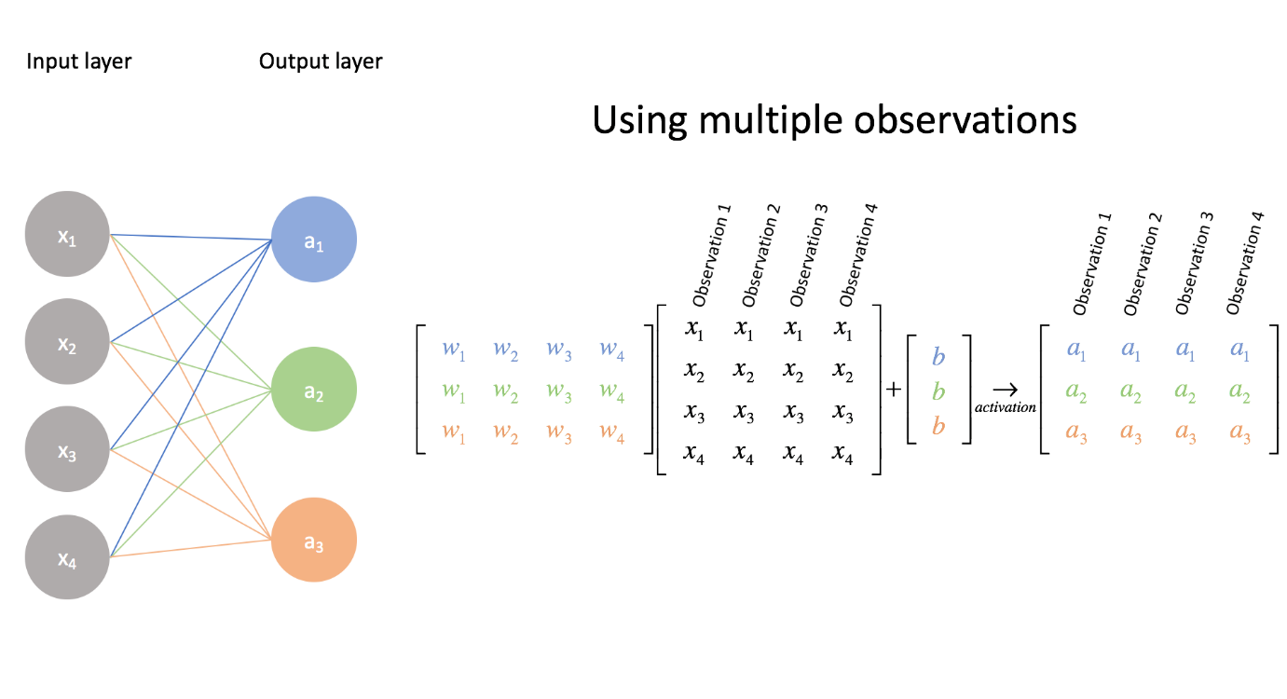Fig.4. Matrix representation of the NN

**Hidden layer**

In order to find the activation values of the nodes in the next layer, a dot product operation can be done between one matrix with another. With the above diagram, we perform the operation between the matrix representing the weights between the input and hidden layer and the matrix representing the input layer in order to product the activation values in the hidden layer. The diagram above has not included the activation function however. So upon obtaining each values from performing the multiplication, we apply the activation function on each of the values in the result in order to find activation value of the nodes. We can do the same operation in order to find the output layer values. Through linear algebra operations we can simplify the feedforward algorithm especially programmatically.

However running the feed forward on a neural network for the very first time may not operate and produce a result that is expected. That is due to the fact that it is untrained. The neural network must learn from already existing data in order to help it produce a more accurate guess. As I have pointed earlier, the weights between each layer greatly influence the activation values of the next neuron. We can also see them as the decision makers of the network. As the weights are randomly initialized, they will likely produce inaccurate activation values in the next node. So from that idea, when training the neural network, what really is happening in the background is that the weights are being adjusted towards a more accurate value.

A concept found in supervised learning is the idea of errors. This is very similar to how humans learn from making mistakes. We compare our work with the actual answer and to use the mistakes we have learnt to adjust our current knowledge. So in the case of neural networks, we make it produce a guess for a particular set of inputs and to compare its guess with the actual answer that is correlated to that set of inputs. Let’s put this mathematically:

$error=answer-guess$

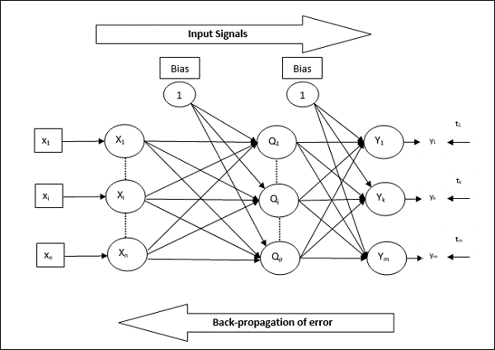Upon discovering the error of the output layer (as the error produced from the overall guess of the NN is the error of the output layer), we use those errors to traverse or propagate back towards the input layer of the NN while at the same time finding the errors of each node in each layer. This is where the mechanism of “backpropagation” comes in (Klein, 2011).

Fig. 5. Feed Forward & Backpropagation

Once we have obtained all the errors of each node in the neural network it will help us to figure out how much we should adjust each of the weights in the networks. The goal of the learning process is the minimize the errors and get them as close to zero as possible. The brings up a new idea of “gradient descent” (Rashid, 2016, pp. 83-93). From this discussion we can conclude that the effectiveness of a neural network is not determined fully by the efficiency of the implementation but by the quality of the training data. As this is a supervised model, the guesses produced by neural networks depend fully on the data it learnt from.

Gaining an understanding on the functionality of a neural network is very important for this project as it is the foundation of many of the core features of the project application. We can see one in use in the next section with regards to Word2Vec.

## 3.2. Word2Vec

Word2Vec is a mechanism that converts words into “word embeddings” or numerical representations of words (TensorFlow, 2018). There are many different ways of creating word embeddings such as TF-IDF vectorisation, count vectors and co-occurrence matrices. However, what is great about Word2Vec is that it maintains the semantical relationships that exist between words. We can illustrate this by performing matrix calculations between word vectors. For example, the word vector produced by:

$vector\left(\text{"}\text{King}\text{"}\right)-vector("Man")+vector("Woman")$

is a vector that is very similar to the word vector of “Queen” (Mikolov, et al., 2013)

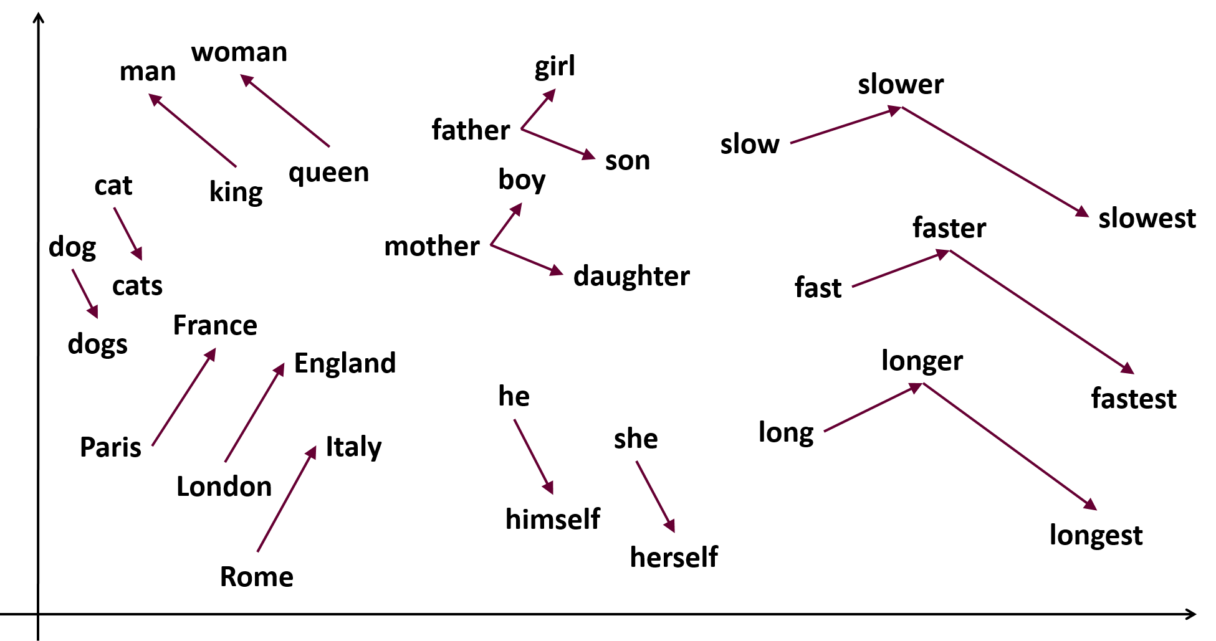

Fig. 6. Vector relationships between words

Word2Vec makes use of shallow neural networks (NN with only one hidden layer) that are trained to do a specific purpose. The two main purposes are described by the two architectures of Word2Vec: Continuous Bag of Words and The Skip-gram model.

**The Skip-gram model**

The skip-gram model is a neural network that is trained predict the neighbouring word (context words) given a specific word in the text corpus.

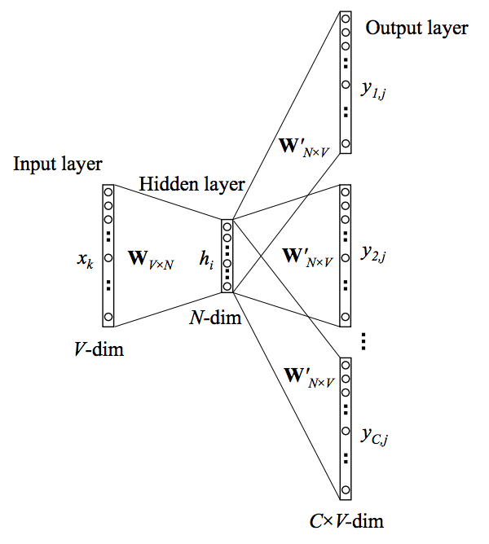Fig. 7. The skip-gram architecture

**Continuous Bag of Words**

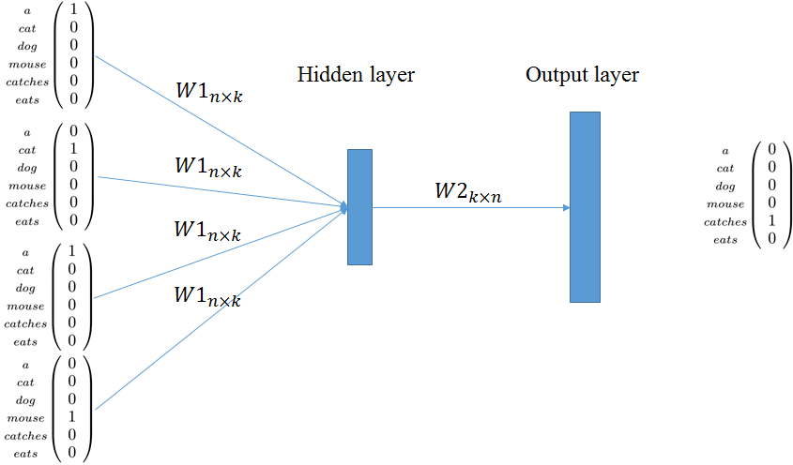Continuous Bag of Words (CBOW) is a neural network that is trained to guess a particular word given the word(s) that surrounds that word.

Fig. 8. The CBOW architecture

As these neural networks are being trained to fulfil their target functions, the weights connecting each layer in their networks are being adjusted towards a more accurate value. It is from these weights that we can derive the word vectors for the words in the text corpus (McCormick, 2016). As I have pointed earlier everything on the neural network can be represented as matrices.

$$\left[\begin{matrix}1.1 & -1.1 & 5.5 \\ 6.3 & 0.02 & 4.2 \\ \begin{aligned}\begin{aligned}2.3 \\ 3.2\end{aligned} \\ 8.3\end{aligned} & \begin{aligned}-1.6 \\ 7.2 \\ 4.9\end{aligned} & \begin{aligned}4.2 \\ 0.6 \\ 4.1\end{aligned}\end{matrix}\right]$$

Fig. 9. The weight matrix representing the weights between the input and hidden layer of a hypothetical Word2Vec model.

We can also represent the input word to the NN like so:

$$\left[0 0 1 0 0\right]$$

Fig. 10. A one-hot representation of the input word “Computer”

In order to find the word vector for the word “Computer” (As an example) we perform a simple dot product between the two matrices.

$$\left[0 0 1 0 0\right]*\left[\begin{matrix}1.1 & -1.1 & 5.5 \\ 6.3 & 0.02 & 4.2 \\ 2.3 & -1.6 & 4.2 \\ 3.2 & 7.6 & 0.6 \\ 8.3 & 4.9 & 4.1\end{matrix}\right]=\left[\begin{matrix}2.3 & -1.6 & 4.2\end{matrix}\right]$$

By doing such an operation, what we’re really doing is that we’re selecting the word vector from all the stored weights representing all the possible words in the corpus and this selected word is projected into the hidden layer. So from the above example the word embedding for the word computer is: $\begin{matrix}[2.3 & -1.6 & 4.2\end{matrix}]$

# Current Progress & Future Plan

NOT YET COMPLETED

# References

Aggarwal, C. C. & Zhai, C., 2012. A Survey of Text Classification Algorithms. *Mining Text Data,* January.pp. 163-222.

Klein, B., 2011. *Backpropagation in Neural Networks.* [Online]   
Available at: https://www.python-course.eu/neural_networks_backpropagation.php  
[Accessed 16 Oct 2018].

Korde, V. & Mahender, N., 2012. Text Classification and Classifiers: A Survey. *International Journal of Artificial Intelligence & Applications (IJAIA),* 3(2), p. 85.

McCormick, C., 2016. *Word2Vec Tutorial - The Skip-Gram Model.* [Online]   
Available at: http://mccormickml.com/2016/04/19/word2vec-tutorial-the-skip-gram-model/  
[Accessed 20 October 2018].

Mikolov, T., Chen, K., Corrado, G. & Dean, J., 2013. *Efficient Estimation of Word Representations in Vector Space.* Arizona, Proceedings of Workshop at ICLR.

Nielsen, M., 2018. *Using neural nets to recognize handwritten digits.* [Online]   
Available at: http://neuralnetworksanddeeplearning.com/chap1.html  
[Accessed 15 Oct 2018].

Rashid, T., 2016. *Make Your Own Neural Network.* Germany: CreateSpace Independent Publishing Platform.

Rosenblatt, F., 1958. The Perceptron: A probabilistic model for information storage and organization in the brain. *Psychological Review ,* 65(6), pp. 386-388.

Stergiou, C. & Siganos, D., n.d. *Neural Networks.* [Online]   
Available at: https://www.doc.ic.ac.uk/~nd/surprise_96/journal/vol4/cs11/report.html#References  
[Accessed 24 December 2018].

TensorFlow, 2018. *Vector Representations of Words.* [Online]   
Available at: https://www.tensorflow.org/tutorials/representation/word2vec  
[Accessed 17 October 2018].